Handouts for communication skills
To develop communication skills, one should practice.
Listening: - for 20 to 30 min
- Podcasts
- Debates
- Tedtalks
- BBC 6min English Channel to develop vocabulary.
- Listen and Repeat English channels.
- Songs
- Movies.
- Phrases
- Understand stress and syllables.
- Disney movies
- Disney cartoons etc.
Speaking: -
- Practice mind talk, Self-talk, and Cross talk.
- Record your own speech and listen.
- Speak to Alexa.
- Have partners and speak to them.
- Spoken English Apps
Reading
- Read at least 20 to 30 min daily aloud.
- Any article, newspaper,
Writing
Draft a story at least one page.
How to build vocabulary
Take one word and build Synonyms and Antonyms and start using them while speaking.
Record your speech and listen to your own speech and compare it to your favorite speakers.

Take a self-test.
https://learnenglish.britishcouncil.org/english-levels/online-english-level-test/
https://www.cambridgeenglish.org/test-your-english/
https://www.youtube.com/watch?v=uhYHpVROC7I
https://www.bbc.co.uk/learningenglish/english/features/the_pronunciation_lounge/episode_1
https://www.youtube.com/watch?v=TR0JZiapxXM&t=309s

https://www.bbc.co.uk/learningenglish/english/features/the_pronunciation_lounge/episode_8
Sentence stress
https://www.youtube.com/shorts/6lSseRcPSMY
https://www.youtube.com/watch?v=ROXGNVEIrrc ( Bridge to Therabithyia)
9 TED Talks that will elevate your career. (short, quick, powerful, and free.) ➟ If you feel stuck in your role ➟ If you’re coasting on autopilot ➟ If you’re done playing small These TED Talks won’t just inspire you. They will teach you how to win. Start right here. 👇 1. How to Figure Out What You Really Want Speaker: Ashley Stahl About: A 3-circle method to align your interests, skills, and values. Why Watch: To gain clarity if you feel directionless in your career. 🔗 https://lnkd.in/g6vCZ5vE - - - 2. 10 Ways to Have Better Conversations Speaker: Celeste Headlee About: 10 clear tips to improve everyday conversations. Why Watch: To connect better and be genuinely heard. 🔗 https://lnkd.in/gZEwmBtj - - - 3. How to Build (and Rebuild) Trust Speaker: Frances Frei About: The 3 foundations of trust: logic, empathy, and authenticity. Why Watch: To lead teams with more credibility and care. 🔗 https://lnkd.in/g2JbjpM5 - - - 4. The Power of Vulnerability Speaker: Brené Brown About: Why openness and emotional honesty build a real connection. Why Watch: To become a more grounded, resilient leader. 🔗 https://lnkd.in/gc8Nzbq7 - - - 5. The Happy Secret to Better Work Speaker: Shawn Achor About: How positivity drives higher performance and success. Why Watch: To shift mindset and see fast productivity gains. 🔗 https://lnkd.in/gVeMg_dn - - - 6. Why We All Need Emotional First Aid Speaker: Guy Winch About: Tools to treat emotional wounds like physical ones. Why Watch: To recover faster from stress, failure, or rejection. 🔗 https://lnkd.in/gv3fiwSX - - - 7. The Career Advice You Didn’t Get Speaker: Susan Colantuono About: Why business skills matter more than soft skills for promotion. Why Watch: To grow beyond mid-level roles with confidence. 🔗 https://lnkd.in/g-Q9ewca - - - 8. Why Listen to People You Disagree With Speaker: Zachary R. Wood About: The value of listening across lines of disagreement. Why Watch: To lead better in diverse or divided environments. 🔗 https://lnkd.in/gDYZSfve - - - 9. What I Learned from 100 Days of Rejection Speaker: Jia Jiang About: Facing rejection repeatedly to build emotional strength. Why Watch: To grow your courage and try without fear. 🔗 https://lnkd.in/gNrmuMYP TED Talks are free training for your growth. Pick one. Watch it. And start advancing your career. 👉 Follow me Andrew Bolis for more and 🔁 Repost this to help others in your network
- 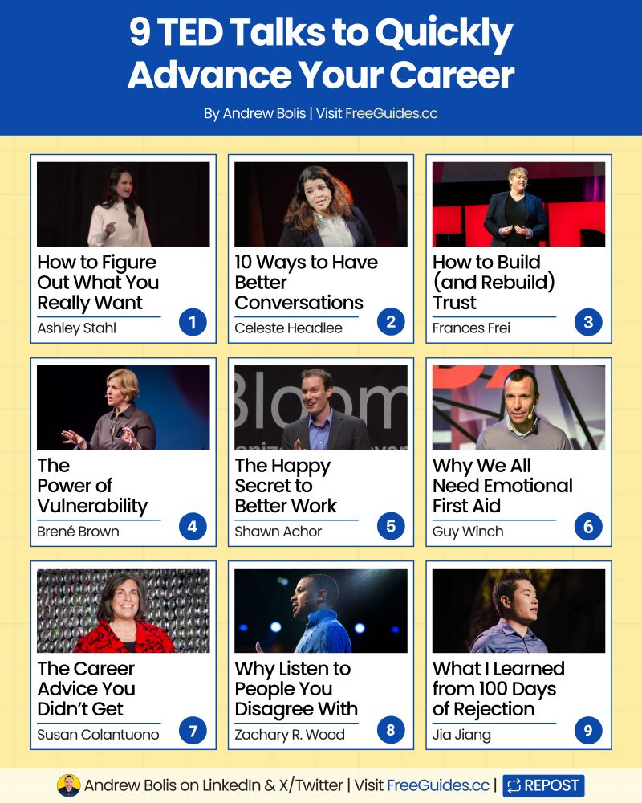
📌 Copy and paste these ChatGPT prompts to learn anything 10X faster. Break down any skill. Practice smarter. Build lasting knowledge. Use these top 10 ChatGPT prompts: 📚 Prompt 1: Concept Breakdown System Simplify [difficult topic] using the Feynman Technique. Explain core ideas in simple language a 12-year-old would understand. Create connections to familiar concepts. Design progressive complexity levels. Include knowledge check questions that reveal true understanding gaps. Topic: [Your Topic]. 📚 Prompt 2: Learning Roadmap Creator Build a personalized learning path for [skill/subject]. Identify essential knowledge vs. nice-to-know details. Map dependencies between concepts. Create milestone checkpoints with specific mastery criteria. Design a progress tracking system with motivation triggers. Subject: [Your Subject]. Goals: [List Goals]. 📚 Prompt 3: Mental Model Builder Connect [new concept] to your existing knowledge. Create 3 powerful analogies that make abstract ideas concrete. Show precisely where each comparison works and breaks down. Include practical examples that demonstrate real understanding. Subject: [Your Subject].
- 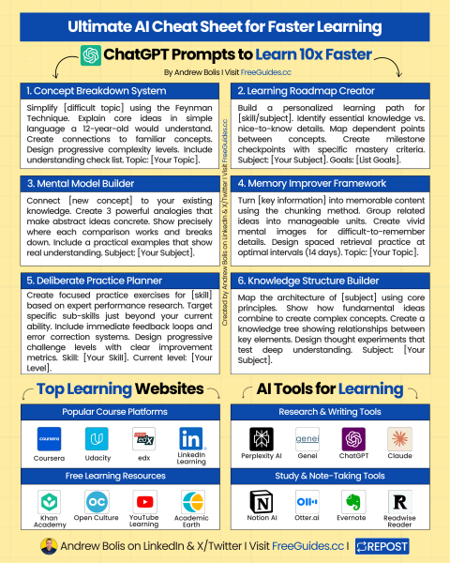
- 
https://www.youtube.com/watch?v=uhYHpVROC7I

